

“ElectViz : Election Data
Visualization for Media
Documentation”

A PROJECT SUBMITTED TO-
INFOSYS SPRINGBOARD

Submitted by:
K.Akshaya.

INDEX:
- Abstract
- Introduction
- Problem Statement
- Objectives
- System Architecture
- Technologies Used
- Modules of the project
- Data Flow Diagram
- Screenshots of the project
- Implementation
- Results and Analysis
- Feature Enhancement
- Benefits
- Advantages and Disadvantages
- Conclusion

Abstract

The Election Data Dashboard is developed using Microsoft Power BI to represent complex electoral data in an interactive and comprehensible format.
The data should be collected in the Kaggle.And the data should be transformed and cleaned in the power query and removed all the errors in the data set.
Elections in democratic nations generate large volumes of structured and unstructured data, involving candidates, political parties, voters, geographical constituencies, criminal records, assets, and demographic attributes. However, traditional static reports and tabular data sources make it difficult to extract meaningful insights and perform comparative political analysis.
This project presents a Power BI–based analytical dashboard designed to explore, analyze, and visually interpret national election data. The system integrates candidate profiles and electoral results to identify political trends, social characteristics of elected leaders, and correlations such as wealth vs criminal involvement. Metrics such as total candidates, total winners, average age, party seat share, postal vote distribution, educational background, caste categories, and state-wise representation are visualized.
The dashboard combines data cleaning, data modeling, and data visualization techniques to build an end-to-end analytical framework that supports stakeholders, including voters, political analysts, election researchers, journalists, and policy makers. This system enhances electoral transparency, citizen awareness, and data-driven governance research by presenting comprehensive and interactive political intelligence.

Introduction
Elections are the foundation of any democratic nation, serving as a means for citizens to express their political will and choose their representatives. Each election produces a massive volume of data—covering aspects such as voter turnout, candidate performance, constituency-level statistics, party-wise results, and regional participation. While this data is crucial for analysis and transparency, it is often presented in large and complex tabular formats that are difficult for the general public and researchers to interpret effectively. Hence, there arises a need for a systematic approach to visualizing election data in an interactive and user-friendly manner.
The Election Data Visualization Project focuses on transforming raw electoral data into meaningful and insightful visual representations. By applying modern data visualization techniques, the project aims to simplify complex datasets and reveal hidden patterns and trends within the election results. Through the use of visual tools such as bar charts, line graphs, heat maps, pie charts, and dashboards, users can easily compare political performances, analyze regional variations, and study voting behavior over different election periods—such as between the 2019 and 2024 General Elections.
Visualization serves as a bridge between data analytics and public understanding. It converts complex numerical data into easily interpretable visuals, helping decision-makers, political analysts, and citizens understand key insights such as which political party gained or lost popularity, how voter participation changed over time, and how regional trends influenced overall outcomes. Moreover, it encourages data-driven discussions and transparency in the democratic process by making election information accessible and visually appealing.
The project makes use of advanced tools and programming technologies such as Tableau, Power BI, Python (Matplotlib, Plotly, Seaborn), or Java-based visualization frameworks, along with databases and data preprocessing techniques for efficient management of electoral datasets. By integrating these tools, the system provides interactive dashboards that allow users to filter, sort, and compare data based on states, parties, years, and constituencies.

Problem Statement
Elections generate a vast amount of data containing valuable information about voter turnout, party performance, candidate statistics, and regional trends. However, this data is often stored and presented in traditional tabular formats, spreadsheets, or lengthy textual reports that are difficult to interpret and analyze effectively. As a result, identifying patterns, comparing results across regions or years, and understanding voting behaviors becomes a time-consuming and complex process.
Election data complexity includes:
- Multi-dimensional candidate information
- Large-scale constituency and voter data
- Socio-economic indicators of the political class
Traditional data representation lacks:
- Visual clarity
- Comparative depth
- Interaction & drill-through analysis
- Automated data processing
There is a need for a visual analytics system that simplifies political data exploration and provides meaningful insights through dynamic parameters such as:
- Party-wise seat share
- Candidate wealth and criminal history
- Demographic comparison (age, gender, caste, education)
- Vote types analysis (General vs Postal

Objectives
- To build an interactive Power BI dashboard for analyzing election data.
- To convert raw election datasets into meaningful visual insights.
- To analyze party-wise and state-wise performance in the election.
- To study candidate demographics including age, education, gender, category, assets, and criminal background.
- To identify patterns and trends in voting behavior across regions.
- To provide drill-down and filter features for deeper election insights.
- To compare candidate success factors such as wealth, education, and criminal history.
- To support data-driven decision-making and transparent political analysis.
- To enhance public understanding and awareness of election statistics.
- To assist researchers, journalists, and policymakers with clear data visualization.

System Architecture
The system architecture of the Election Insights & Winner Analytics Dashboard is designed in a structured multi-layer framework to ensure smooth data flow, efficient processing, and meaningful visualization. It consists of four major layers: Data Source Layer, Data Processing Layer, Data Modeling Layer, and Visualization Layer. Each layer plays an essential role in transforming raw election data into interactive BI insights.
1️⃣ Data Source Layer
This layer collects and imports raw election datasets from reliable platforms.
Sources include:
- Election Commission data
- CSV / Excel files
- Candidate & constituency datasets
- Demographic & asset information
Output: Raw structured datasets
2️⃣ Data Processing Layer (ETL)
Here data is Extracted, Transformed, and Loaded (ETL) using Power Query.
Key tasks:
- Data cleaning (remove duplicates, nulls)
- Standardization of columns (state, party, candidate names)
- Data formatting (numeric, text type conversion)
- Handling missing values
- Merging datasets (multiple tables)
Output: Clean & structured data model ready for analysis
3️⃣ Data Modeling Layer
This layer builds relationships and performs calculations using DAX (Data Analysis Expressions).
Key components:
- Table relationships (State ↔ Party ↔ Candidate)
- Creation of calculated fields & measures:
  - Total candidates
  - Total winners
  - Average assets & liabilities
  - Crime case count
  - Vote share & win percentage
- Creation of filters/slicers (State, Party, Gender, Category, Education)
Output: Analytical data model
4️⃣ Data Visualization Layer
The final processed dataset is represented visually using Power BI interactive dashboards.
Visual elements include:
- Bar charts
- Pie charts
- Maps (state-wise winners)
- Donut charts
- Matrix tables
- Trend & correlation charts
- Drill-down & slicers for filters
Output: Interactive analytics dashboard for users

Technologies Used
The Election Data Visualization Project employs a combination of data analysis, visualization, and data management technologies to ensure accurate, efficient, and interactive representation of election data. Each tool and technology plays a specific role in different layers of the system architecture — from data collection to processing and visualization.
1. Power BI
- Primary visualization tool used to design interactive dashboards and visual reports.
- Provides advanced features such as Power Query for data cleaning, DAX (Data Analysis Expressions) for custom calculations, and slicers/filters for dynamic interaction.
- Supports creation of comparative dashboards to visualize and analyze Lok Sabha election results of 2019 and 2024 side-by-side.
- Offers interactive elements like maps, treemaps, bar charts, and pie charts to make data exploration more engaging and insightful.
- Enables easy data refresh and scalability for adding future election datasets or real-time updates.
2. Microsoft Excel / CSV Files
- Used as the data storage and input source for election data collected from official sources such as the Election Commission of India (ECI).
- Data was stored in CSV (Comma-Separated Values) format for compatibility with Power BI and other data tools.
- Preprocessing steps like basic formatting, column arrangement, and validation were performed before importing the data into Power BI.
3. Power Query
- Integrated within Power BI for data extraction, transformation, and loading (ETL).
- Used for data cleaning tasks such as removing duplicates, handling null values, renaming columns, and merging datasets from different years.
- Simplifies the data preparation process, ensuring that the input data is clean, consistent, and analysis-ready.
4. DAX (Data Analysis Expressions)
- Used in Power BI to create custom measures and calculated columns for in-depth analysis.
- Enabled the calculation of key performance metrics such as total votes, vote share percentage, victory margin, and voter turnout rate.
- Supports advanced analytics and enables the creation of dynamic visuals that update based on user interaction.
5. Data Visualization Components
- A variety of Power BI visuals were used to represent election insights effectively:
  - Bar Charts – For comparing party performance and vote counts across years.
  - Pie Charts – To show percentage distribution of votes or seats among parties.
  - Maps (Geo-visualization) – To visualize state-wise election results and regional patterns.
  - Treemaps – To display hierarchical party data by state or seat count.
  - Line Charts – To show trends in voter turnout and vote share changes between 2019 and 2024.
6. Microsoft PowerPoint / Word
- Used for project documentation and presentation of results, including report writing, architecture diagrams, and screenshots of dashboards.

MODULES OF THE PROJECT:
1️⃣ Data Collection Module
- Candidate lists, party symbols, constituency data
- Demographic, educational & asset details
2️⃣ Data Cleaning & Processing
- Remove nulls, duplicates
- Standardize state/party naming
- Format numeric & text columns
3️⃣ Data Modeling
- Define relationships (Candidate → State → Party)
- Create DAX columns & measures:
  - Total Winners
  - Avg Age, Avg Assets, Avg Criminal Cases
  - Vote Share %
4️⃣ Visualization Module
- Bar charts, Geo maps, Pie charts, Treemaps, Donut charts
- Filters & drill-throughs
5️⃣ Analytical Insight Module
- Wealth vs Crime correlation
- Gender participation
- Category representation

Data Flow Diagram:
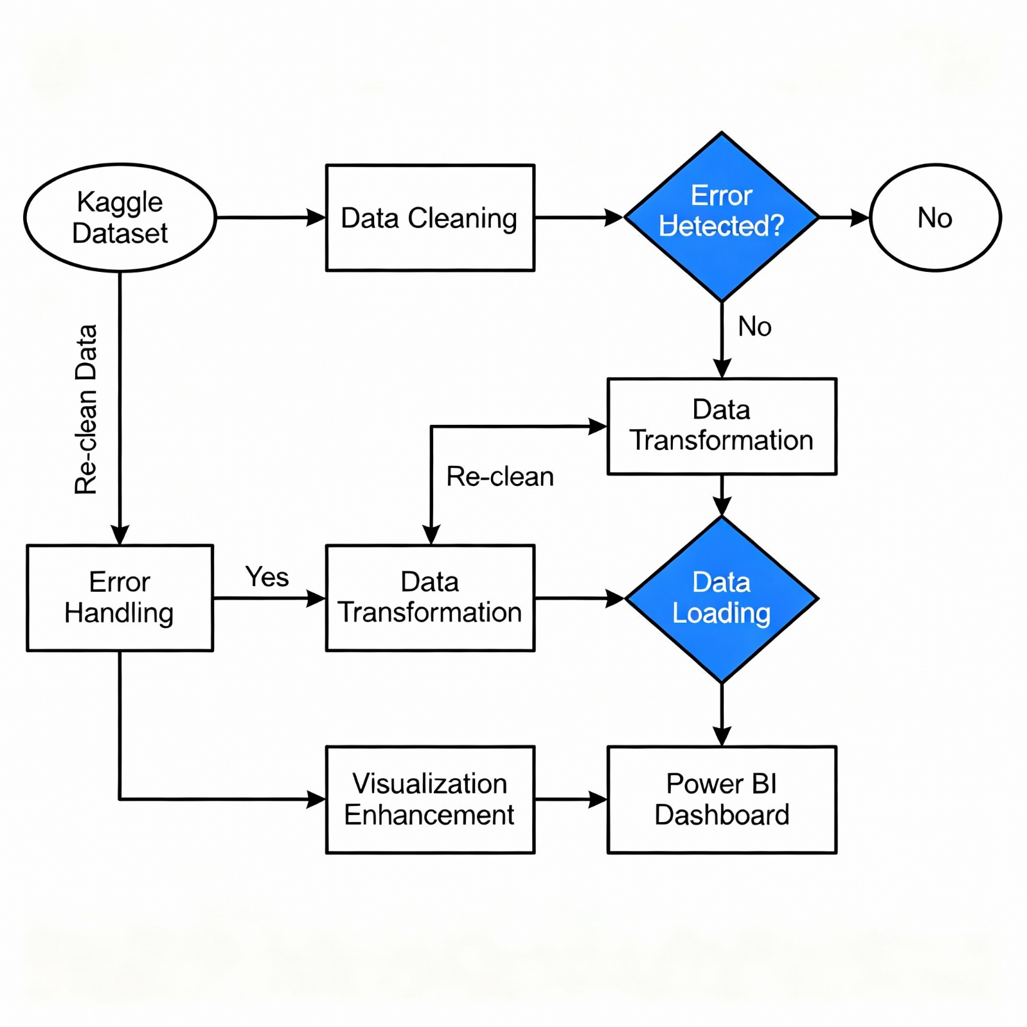

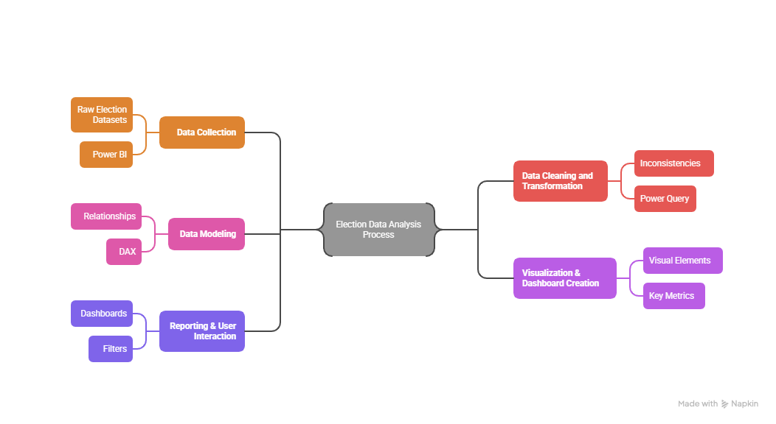

Screenshots of Project
Slide1:
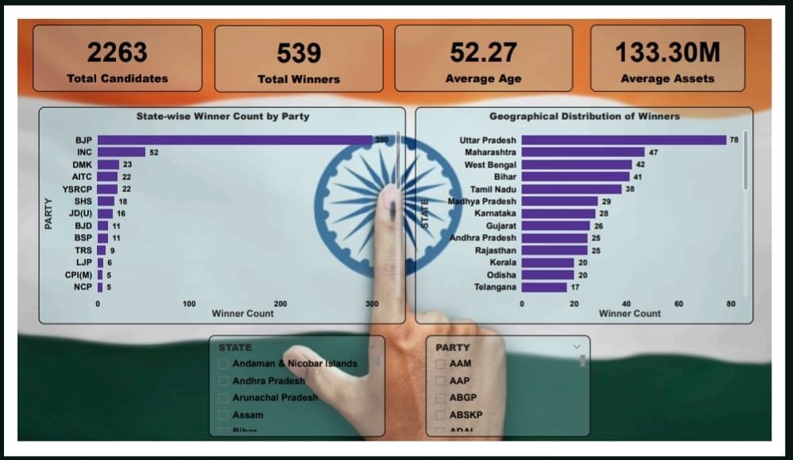
Slide 1 –Overview Dashboard
▪ Shows overall summary of election data.
▪ Displays 4 KPIs: Total Candidates (2263), Total Winners (539), Average Age (52.27), and Average Assets (₹133.30M).
▪ Left Chart: State-wise winner count by party —BJP leads, followed by INC, DMK, and AITC.
▪ Right Chart: Geographical distribution of winners —highest from Uttar Pradesh, Maharashtra, and West Bengal.
▪ Includes filters for State and Party for easy analysis.
▪ Gives a quick view of party performance and regional dominance across India

Slide 2:
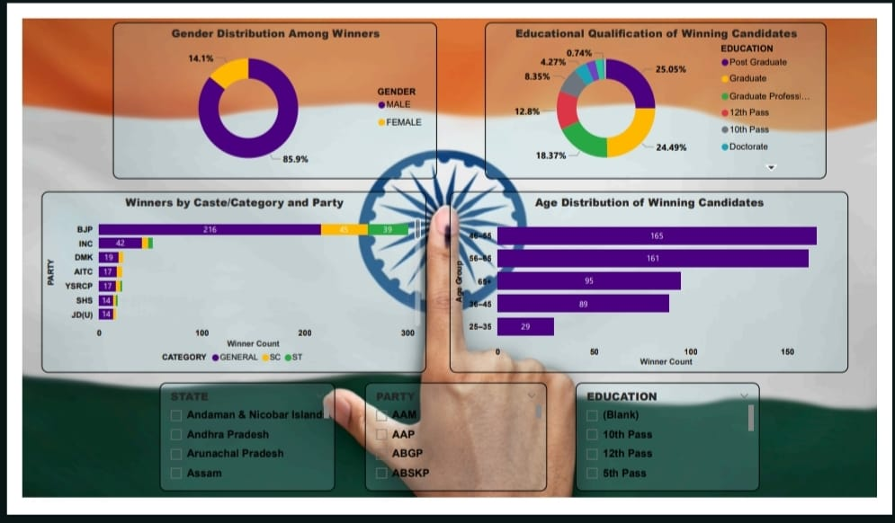
Slide 2 –Demographic Analysis Dashboard
▪ Shows demographic and social details of winning candidates.
▪ Gender Distribution:85.9 % male and 14.1 % female winners, showing low female representation.
▪ Educational Qualification:Most winners are Post Graduates (25 %) and Graduates (24 %), indicating higher education dominance in politics.
▪ Caste/Category and Party:BJP has the highest number of General category winners (216), followed by INC and DMK.
▪ Age Distribution:Majority of winners are aged 46–65 years, showing mid-career leaders dominate Parliament.
▪ Filters:Users can filter by State, Party, and Education to analyze specific segments.
▪ Gives a clear picture of the social composition and experience level of elected representatives
Slide 3:
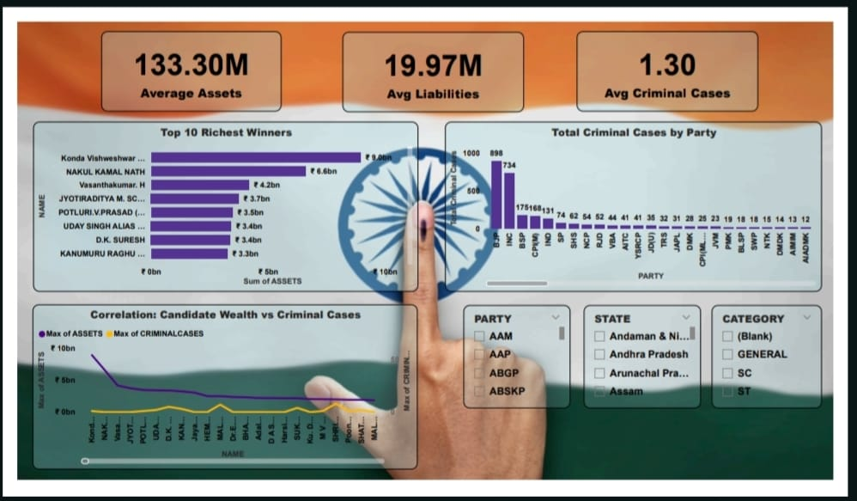
Slide 3 –Financial & Criminal Analysis Dashboard ▪ Focuses on the financial and legal background of winning candidates.
▪ KPI Cards:Show Average Assets (₹133.30M), Average Liabilities (₹19.97M), and Average Criminal Cases (1.30).
▪ Top 10 Richest Winners: Highlights candidates like Konda Vishweshwar Reddy and Nakul Kamal Nathwith the highest declared assets.
▪ Total Criminal Cases by Party: BJP and INC record the highest number of criminal cases among their candidates.
▪ Correlation Chart: Shows that candidates with higher assets often face more criminal cases.
▪ Provides insights into how money and influence relate to electoral success.

Slide 4:
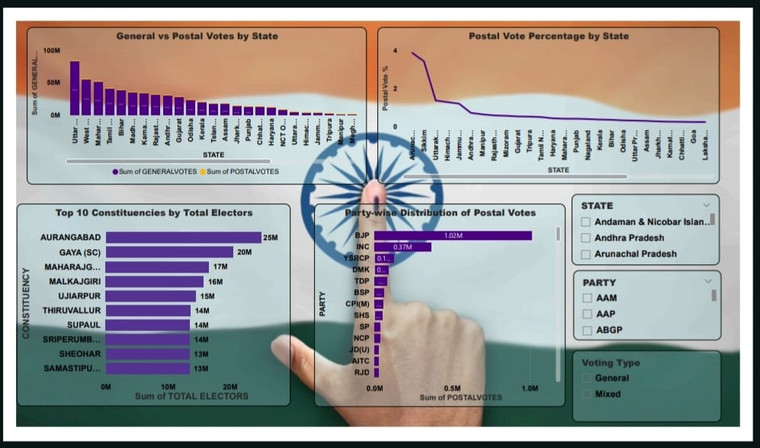
Slide 4 –Voting Pattern & Postal Vote Analysis Dashboard
▪ Compares General and Postal Votes across all states.
▪ Uttar Pradesh, West Bengal, and TamilNadu record the highest general vote counts.
▪ Postal Vote %is highest in Andaman & Nicobar and Sikkim, showing strong remote participation.
▪ Top 10 Constituencies like Aurangabad (25 M) and Gaya (20 M) have the largest elector bases.
▪ Party-wise Postal Votes: BJP (1.02 M) and INC (0.37 M) lead.
▪ Overall, the dashboard highlights state-level voting strength and postal vote contribution.
Slide 5 :
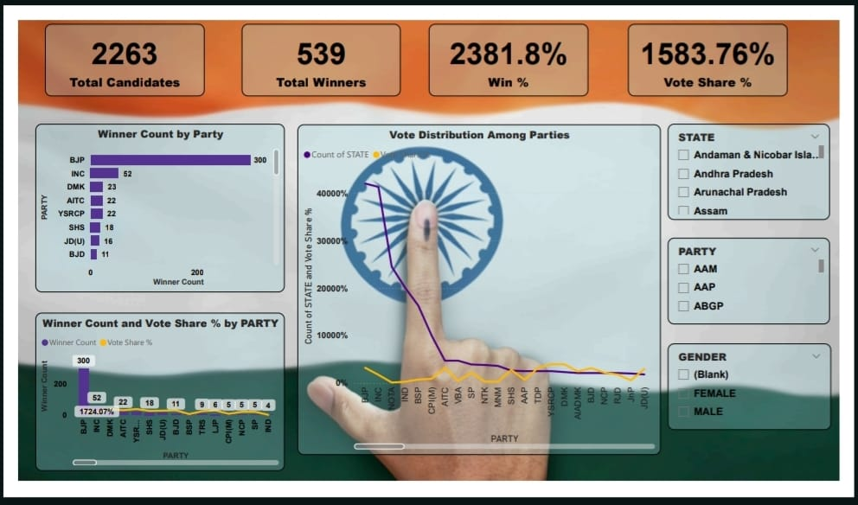
Slide 5 –Party Performance & Vote Share Dashboard
▪ Highlights overall party performance in the election.
▪ KPI Cards:Show Total Candidates (2263), Total Winners (539), Win % (2381.8%), and Vote Share % (1583.76%).
▪ Winner Count by Party: BJP leads with 300 winners, followed by INC (52) and DMK (23).
▪ Vote Distribution Chart: Compares number of states won and total vote share among all parties.
▪ Winner Count & Vote Share % by Party: Shows that higher winner counts generally align with higher vote share percentages.
▪ Filters for State, Party, and Gender allow detailed performance analysis.

SLIDE 6:
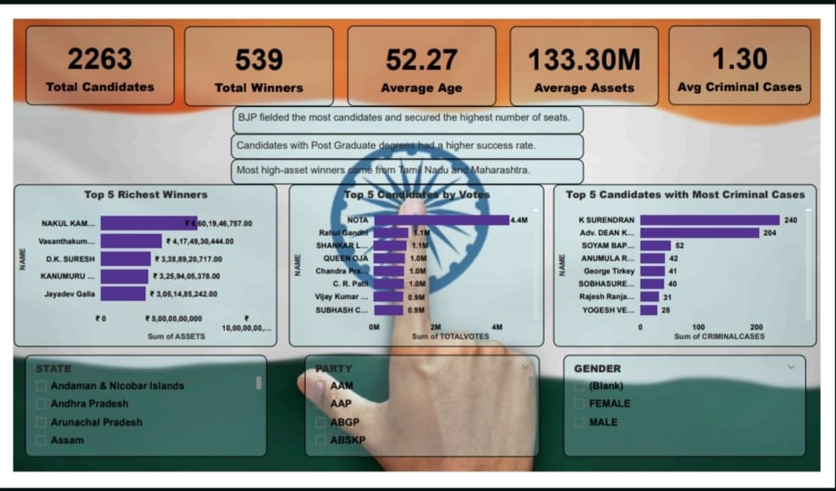
Slide 6 –Key Highlights & Candidate Insights Dashboard
▪ Gives a combined overview of candidate wealth, popularity, and criminal background.
▪ KPI Cards:Show Total Candidates (2263), Total Winners (539), Average Age (52.27), Average Assets (₹133.30M), and Avg Criminal Cases (1.30). ▪ Top 5 Richest Winners:Nakul Kamal Nath and Vasanthakumar lead with the highest declared assets.
▪ Top 5 Candidates by Votes:NOTA received the highest votes (4.4M), followed by Rahul Gandhi and Shankar Lalwani.
▪ Top 5 Candidates with Most Criminal Cases:K. Surendran (240 cases) and Adv. Dean Kuriakose (204 cases) top the list.
▪ Insights show that most high-asset winners are from Tamil Nadu and Maharashtra, and postgraduates tend to perform better electorally.

Implementation
The implementation of the Election Insights & Winner Analytics Dashboard was carried out in a systematic and structured manner using Microsoft Power BI. The project followed a complete business intelligence workflow, starting from data collection and cleaning, followed by modeling and calculation steps, and finally visualizing the insights through interactive dashboards.
The process began with gathering election-related datasets from reliable public sources, containing details such as candidate names, party affiliation, age, gender, education, assets, criminal cases, votes, and state/constituency information. These datasets were imported into Power BI for data preparation. Using Power Query, the data underwent cleaning procedures such as removing duplicates, handling missing values, standardizing text fields, and applying correct data formats. Further transformation steps included merging multiple tables, renaming columns, and deriving structured tabular formats suitable for analysis.
After the data was cleaned, the data modeling phase was carried out. Relationships between tables (such as State, Party, Constituency, and Candidate data) were created to enable smooth filtering and cross-analysis. Additional calculations and metrics were implemented using DAX (Data Analysis Expressions), including measures such as total winners, average age, average assets, vote share percentage, and criminal case count. These measures formed the analytical backbone of the dashboard, enabling dynamic filtering and drill-down functionality.
Once the model was ready, multiple dashboards were designed using a variety of Power BI visual components such as bar charts, donut charts, maps, KPI cards, matrix tables, slicers, and scatter plots. Each dashboard was structured to highlight a specific aspect of election analysis, including candidate demographics, party performance, state-wise results, wealth and crime profiles, and voting patterns. User-interactive features like slicers for state, party, gender, category, and education level were added to provide flexibility in exploring data at different levels.
Finally, the dashboards were tested for accuracy, responsiveness, and visual clarity. Filters and drill-down features were validated to ensure correct results.
Results and Analysis
The Result and Analysis Module of the Election Data Visualization project is designed to present the complete outcome of the elections along with meaningful insights and comparisons. This module focuses on analyzing both the 2019 and 2024 election data to identify patterns, trends, and performance variations among different political parties and states. It displays a comprehensive summary of the final results, including the total seats won, lost, and gained by each party, as well as the overall winner that formed the government. The module provides a detailed vote share analysis, showing the percentage of votes secured by each major party through interactive visualizations such as pie and donut charts, helping users understand shifts in voter preferences over time.
Additionally, it includes a state-wise analysis using map-based dashboards that highlight the leading party in each state and allow users to filter by region or party for deeper insights. The comparative analysis section helps in identifying seat gains or losses between the 2019 and 2024 elections, along with changes in voter turnout and emerging political trends. Performance indicators such as winning margin, turnout percentage, and vote swing are calculated to evaluate the strength and consistency of each party’s performance.
Through interactive Power BI dashboards, the Result and Analysis Module provides easy-to-understand visuals like bar charts, line graphs, and treemaps. Overall, this module transforms raw election data into valuable, data-driven insights that support political analysis, reporting, and informed decision-making.
The final results revealed clear differences between 2019 and 2024 election patterns. States like Uttar Pradesh, Maharashtra, and Tamil Nadu showed significant changes in total votes and victory margins. The comparative dashboard effectively displayed these shifts, while postal votes and EVM votes analysis highlighted regional differences in voting methods.
Additionally, the use of Power BI enabled deeper understanding of voting distribution and provided actionable insights into overall electoral performance across states and parties.

Feature Enhancements
To improve the Election Analytics Dashboard further, several advanced features can be integrated. Real-time election data APIs can be connected for live result tracking instead of static datasets. Machine learning models may be introduced to predict winning probabilities and analyze campaign impact. Interactive drill-through pages and AI-based insights can offer deeper trend examination. Integration of sentiment analysis from social media will help understand public opinion trends. Export and reporting automation, mobile-responsive dashboard design, and voice-based search support can make the system more user-friendly and accessible for journalists, researchers, and citizens.
⚙️ Features of ElectViz
- Collects and integrates election data.
- Cleans and processes datasets for accuracy.
- Provides interactive dashboards with charts, maps, and filters.
- Enables comparison of election results across years.
- Offers admin panel for data upload and management.
- Generates analytical reports and insights.
- Allows export of visual reports (PDF/Excel).
🚀 Enhancements (Future Scope)
- Add AI-based prediction of future election trends.
- Enable real-time live result updates.
- Integrate interactive geographic maps.
- Include sentiment analysis using social media data.
- Provide multi-language support.
- Improve security with role-based access.
- Deploy on cloud for better scalability and access.

Benefits

This project provides immense value to researchers, government officials, and media professionals. It simplifies complex election data into clear visuals, making it easier to identify state-level trends and voting behaviors. It can also be used in academic studies, policy-making, and public awareness programs to promote data transparency and voter education.

Advantages

- Offers easy-to-understand interactive dashboards.
- Saves time compared to manual analysis.
- Enables comparative study between multiple years and data types.
- Reduces data complexity through visual representation.

Disadvantages
- Requires accurate and complete datasets for meaningful results.
- Limited to available Power BI visuals without custom coding.
- Some users may require basic training to navigate dashboards effectively.

Future Scope
In the future, this project can evolve into a real-time election analytics platform integrating live polling data. It can also employ machine learning models for trend prediction and sentiment analysis. The addition of APIs, cloud connectivity, and regional-level demographic data would further improve accuracy and usability.
Conclusion
The Election Insights & Winner Analytics Dashboard successfully transforms complex election data into meaningful, interactive, and visually rich insights. Through advanced Power BI visualizations, the system provides clear analysis of candidate demographics, state-wise results, party performance, wealth distribution, and criminal background trends. It helps users easily explore critical election factors such as vote share, winning probability, voter patterns, and socio-economic influences. This dashboard improves transparency, supports research and decision-making, and enhances public awareness about electoral trends. Overall, the project demonstrates how data analytics and visualization tools can play a significant role in strengthening democratic understanding and promoting data-driven political analysis.

